2013 年 AMC 8 真题与解答
American Mathematics Competitions 8 · 中英双语
共 25 题，限时 40 分钟；单项选择题，每题 1 分，答错不扣分，满分 25 分。
内容来源：LIVE by Po-Shen Loh（live.poshenloh.com）历年 AMC 8 真题与解答，试题经美国数学协会（MAA）官方授权使用；本文档由本地整理生成，供个人学习使用，版权归原作者及 MAA 所有。
编排说明：第一部分为题目（先中文、后英文原题），第二部分为解答与答案，便于先做题后对答案。
第一部分 题目
第 1 题
丹妮卡想把她的模型车排成若干行，每行正好 6 辆。她现在有 23 辆模型车。为了能用这种方式排好所有车，她最少还需要买多少辆？
（A）1 （B）2 （C）3 （D）4 （E）5
English
Danica wants to arrange her model cars in rows with exactly 6 cars in each row. She now has 23 model cars. What is the smallest number of additional cars she must buy in order to be able to arrange all her cars this way?
(A) 1 (B) 2 (C) 3 (D) 4 (E) 5
第 2 题
鱼市的招牌写着：“仅限今天，50 % 折扣：半磅装每包只要 $3。”一整磅鱼的正常价格是多少美元？
（A）6 （B）9 （C）10 （D）12 （E）15
English
A sign at the fish market says, “50 % off, today only: half-pound packages for just $3 per package.” What is the regular price for a full pound of fish, in dollars?
(A) 6 (B) 9 (C) 10 (D) 12 (E) 15
第 3 题
下列表达式的值是多少？
4 · (-1 + 2 - 3 + 4 - 5 + 6
- 7 + ⋯ + 1000)
（A）-10 （B）0 （C）1 （D）500 （E）2000
English
What is the value of
4 · (-1 + 2 - 3 + 4 - 5 + 6
- 7 + ⋯ + 1000)?
(A) -10 (B) 0 (C) 1 (D) 500 (E) 2000
第 4 题
八个朋友在餐馆吃饭，并同意平均分摊账单。因为朱迪忘带钱，她的七个朋友每人额外支付 $2.50 来替她支付她应付的部分。总账单是多少？
（A）$120 （B）$128 （C）$140 （D）$144 （E）$160
English
Eight friends ate at a restaurant and agreed to share the bill equally. Because Judi forgot her money, each of her seven friends paid an extra $2.50 to cover her portion of the total bill. What was the total bill?
(A) $120 (B) $128 (C) $140 (D) $144 (E) $160
第 5 题
汉米上 6 年级，体重 106 磅。他的四胞胎妹妹还是小婴儿，体重分别为 5、5、6 和 8 磅。这五个孩子的平均体重和中位数哪个更大，大多少磅？
（A）中位数，大 60 磅 （B）中位数，大 20 磅 （C）平均数，大 5 磅 （D）平均数，大 15 磅 （E）平均数，大 20 磅
English
Hammie is in the 6th grade and weighs 106 pounds. His quadruplet sisters are tiny babies and weigh 5, 5, 6, and 8 pounds. Which is greater, the average (mean) weight of these five children or the median weight, and by how many pounds?
(A) median, by 60 (B) median, by 20 (C) average, by 5 (D) average, by 15 (E) average, by 20
第 6 题
下方每个框中的数是它上方一行中与它相接的两个框中数字的乘积。例如，30 = 6×5。
顶行缺失的数是多少？
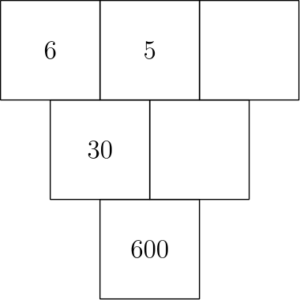
（A）2 （B）3 （C）4 （D）5 （E）6
English
The number in each box below is the product of the numbers in the two boxes that touch it in the row above. For example, 30 = 6×5.
What is the missing number in the top row?
(A) 2 (B) 3 (C) 4 (D) 5 (E) 6
第 7 题
特雷和妈妈在铁路道口停下来让火车通过。火车刚开始通过时，特雷在前 10 秒数到 6 节车厢。火车以恒定速度完全通过道口用了 2 分 45 秒。下列哪一个最可能是这列火车的车厢数？
（A）60 （B）80 （C）100 （D）120 （E）140
English
Trey and his mom stopped at a railroad crossing to let a train pass. As the train began to pass, Trey counted 6 cars in the first 10 seconds. It took the train 2 minutes and 45 seconds to clear the crossing at a constant speed. Which of the following was the most likely number of cars in the train?
(A) 60 (B) 80 (C) 100 (D) 120 (E) 140
第 8 题
一枚公平硬币被抛 3 次。至少出现两个连续正面的概率是多少？
（A）1/8 （B）1/4 （C）3/8 （D）1/2 （E）3/4
English
A fair coin is tossed 3 times. What is the probability of at least two consecutive heads?
(A) 1/8 (B) 1/4 (C) 3/8 (D) 1/2 (E) 3/4
第 9 题
绿巨人浩克每次跳跃的距离都能比上一次翻倍。如果第一次跳 1 米，第二次跳 2 米，第三次跳 4 米，依此类推，那么他第一次能跳超过 1 千米是在第几跳？
（A）第 9 跳 （B）第 10 跳 （C）第 11 跳 （D）第 12 跳 （E）第 13 跳
English
The Incredible Hulk can double the distance he jumps with each succeeding jump. If his first jump is 1 meter, the second jump is 2 meters, the third jump is 4 meters, and so on, then on which jump will he first be able to jump more than 1 kilometer?
(A) 9th (B) 10th (C) 11th (D) 12th (E) 13th
第 10 题
180 和 594 的最小公倍数与 180 和 594 的最大公因数之比是多少？
（A）110 （B）165 （C）330 （D）625 （E）660
English
What is the ratio of the least common multiple of 180 and 594 to the greatest common factor of 180 and 594?
(A) 110 (B) 165 (C) 330 (D) 625 (E) 660
第 11 题
特德的祖父本周有 3 天使用了跑步机。他每天走或跑 2 英里。
星期一他以每小时 5 英里的速度慢跑。星期三他以每小时 3 英里的速度步行，星期五以每小时 4 英里的速度步行。
如果祖父一直以每小时 4 英里的速度步行，他会少花一些跑步机时间。少多少分钟？
（A）1 （B）2 （C）3 （D）4 （E）5
English
Ted’s grandfather used his treadmill on 3 days this week. He went 2 miles each day.
On Monday he jogged at a speed of 5 miles per hour. He walked at the rate of 3 miles per hour on Wednesday and at 4 miles per hour on Friday.
If Grandfather had always walked at 4 miles per hour, he would have spent less time on the treadmill. How many minutes less?
(A) 1 (B) 2 (C) 3 (D) 4 (E) 5
第 12 题
在 2013 年威尼贝戈县集市上，一个摊贩正在对凉鞋推出“集市特价”。如果你以正常价格 $50 买一双凉鞋，第二双打 40 % 折扣，第三双半价。
哈维尔利用这个“集市特价”买了三双凉鞋。与 $150 的正常总价相比，他节省了百分之多少？
（A）25 （B）30 （C）33 （D）40 （E）45
English
At the 2013 Winnebago County Fair a vendor is offering a “fair special” on sandals. If you buy one pair of sandals at the regular price of $50, you get a second pair at a 40 % discount, and a third pair at half the regular price.
Javier took advantage of the “fair special” to buy three pairs of sandals. What percentage of the $150 regular price did he save?
(A) 25 (B) 30 (C) 33 (D) 40 (E) 45
第 13 题
克拉拉计算总分时，不小心把其中一个分数的个位数字和十位数字写反了。她的错误总和与正确总和可能相差下列哪一个数？
（A）45 （B）46 （C）47 （D）48 （E）49
English
When Clara totaled her scores, she inadvertently reversed the units digit and the tens digit of one score. By which of the following might her incorrect sum have differed from the correct one?
(A) 45 (B) 46 (C) 47 (D) 48 (E) 49
第 14 题
艾布手里有 1 颗绿色和 1 颗红色软糖。比娅手里有 1 颗绿色、1 颗黄色和 2 颗红色软糖。两人各随机拿出一颗软糖给对方看。颜色相同的概率是多少？
（A）1/4 （B）1/3 （C）3/8 （D）1/2 （E）2/3
English
Abe holds 1 green and 1 red jelly bean in his hand. Bea holds 1 green, 1 yellow, and 2 red jelly beans in her hand. Each randomly picks a jelly bean to show the other. What is the probability that the colors match?
(A) 1/4 (B) 1/3 (C) 3/8 (D) 1/2 (E) 2/3
第 15 题
如果 3ᵖ + 3⁴ = 90、2^(r) + 44 = 76，且 5³ + 6^(s) = 1421，那么 p、r、s 的乘积是多少？
（A）27 （B）40 （C）50 （D）70 （E）90
English
If 3ᵖ + 3⁴ = 90, 2^(r) + 44 = 76, and 5³ + 6^(s) = 1421, what is the product of p, r, and s?
(A) 27 (B) 40 (C) 50 (D) 70 (E) 90
第 16 题
斐波那契中学的一些学生参加社区服务项目。8 年级学生与 6 年级学生的比为 5:3，8 年级学生与 7 年级学生的比为 8:5。参加该项目的学生最少可能有多少人？
（A）16 （B）40 （C）55 （D）79 （E）89
English
A number of students from Fibonacci Middle School are taking part in a community service project. The ratio of 8th-graders to 6th-graders is 5:3, and the ratio of 8th-graders to 7th-graders is 8:5. What is the smallest number of students that could be participating in the project?
(A) 16 (B) 40 (C) 55 (D) 79 (E) 89
第 17 题
六个连续正整数的和是 2013。这六个整数中最大的是多少？
（A）335 （B）338 （C）340 （D）345 （E）350
English
The sum of six consecutive positive integers is 2013. What is the largest of these six integers?
(A) 335 (B) 338 (C) 340 (D) 345 (E) 350
第 18 题
伊莎贝拉用一英尺见方的立方块搭建一个长方体堡垒，长 12 英尺、宽 10 英尺、高 5 英尺。地板和四面墙都厚一英尺。这个堡垒包含多少块立方块？
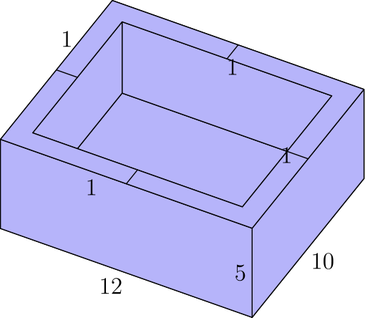
（A）204 （B）280 （C）320 （D）340 （E）600
English
Isabella uses one-foot cubical blocks to build a rectangular fort that is 12 feet long, 10 feet wide, and 5 feet high. The floor and the four walls are all one foot thick. How many blocks does the fort contain?
(A) 204 (B) 280 (C) 320 (D) 340 (E) 600
第 19 题
布里奇特、卡西和汉娜正在讨论上次数学测试的结果。汉娜给布里奇特和卡西看了她的试卷，但布里奇特和卡西没有把自己的试卷给任何人看。卡西说：“我不是班里的最低分。”布里奇特补充说：“我不是最高分。”三位女生从高到低的排名是什么？
（A）汉娜、卡西、布里奇特 （B）汉娜、布里奇特、卡西 （C）卡西、布里奇特、汉娜 （D）卡西、汉娜、布里奇特 （E）布里奇特、卡西、汉娜
English
Bridget, Cassie, and Hannah are discussing the results of their last math test. Hannah shows Bridget and Cassie her test, but Bridget and Cassie don’t show theirs to anyone. Cassie says, “I didn’t get the lowest score in our class,” and Bridget adds, “I didn’t get the highest score.” What is the ranking of the three girls from highest to lowest?
(A) Hannah, Cassie, Bridget (B) Hannah, Bridget, Cassie (C) Cassie, Bridget, Hannah (D) Cassie, Hannah, Bridget (E) Bridget, Cassie, Hannah
第 20 题
一个 1 × 2 长方形内接于一个半圆，较长的一边在直径上。这个半圆的面积是多少？
（A）π/2 （B）2π/3 （C）π （D）4π/3 （E）5π/3
English
A 1 × 2 rectangle is inscribed in a semicircle with the longer side on the diameter. What is the area of the semicircle?
(A) π/2 (B) 2π/3 (C) π (D) 4π/3 (E) 5π/3
第 21 题
萨曼莎住在城市公园西南角以西 2 个街区、以南 1 个街区的地方。
她的学校在城市公园东北角以东 2 个街区、以北 2 个街区的地方。上学日她先沿街骑车到城市公园的西南角，再走公园里的对角线小路到东北角，然后沿街骑车到学校。
如果她的路线尽可能短，她有多少种不同路线可走？
（A）3 （B）6 （C）9 （D）12 （E）18
English
Samantha lives 2 blocks west and 1 block south of the southwest corner of City Park.
Her school is 2 blocks east and 2 blocks north of the northeast corner of City Park. On school days she bikes on streets to the southwest corner of City Park, then takes a diagonal path through the park to the northeast corner, and then bikes on streets to school.
If her route is as short as possible, how many different routes can she take?
(A) 3 (B) 6 (C) 9 (D) 12 (E) 18
第 22 题
用牙签搭成一个长 60 根牙签、高 32 根牙签的网格。一共用了多少根牙签？
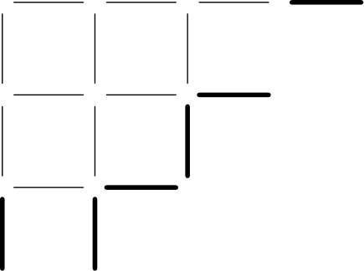
（A）1920 （B）1952 （C）1980 （D）2013 （E）3932
English
Toothpicks are used to make a grid that is 60 toothpicks long and 32 toothpicks high. How many toothpicks are used altogether?
(A) 1920 (B) 1952 (C) 1980 (D) 2013 (E) 3932
第 23 题
在 △ ABC 中，∠ ABC 是直角。如图，△ ABC 的三边分别作为半圆的直径。以 AB 为直径的半圆面积为 8π，以 AC 为直径的半圆的弧长为 8.5π。以 BC 为直径的半圆半径是多少？
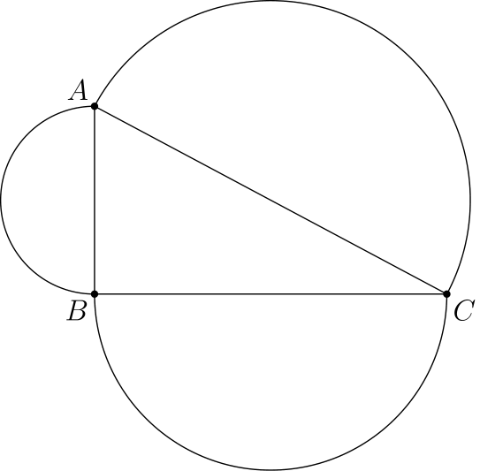
（A）7 （B）7.5 （C）8 （D）8.5 （E）9
English
In △ ABC, ∠ ABC is a right angle. The sides of △ ABC are the diameters of semicircles as shown. The area of the semicircle on AB equals 8π, and the arc of the semicircle on AC has length 8.5π. What is the radius of the semicircle on BC?
(A) 7 (B) 7.5 (C) 8 (D) 8.5 (E) 9
第 24 题
正方形 ABCD、EFGH 和 GHIJ 面积相等。点 C 和 D 分别是边 IH 和 HE 的中点。阴影五边形 AJICB 的面积与三个正方形面积之和的比是多少？
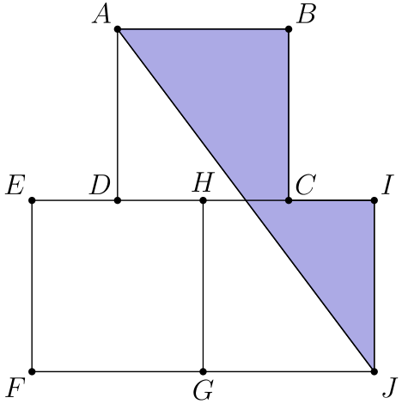
（A）1/4 （B）7/24 （C）1/3 （D）3/8 （E）5/12
English
Squares ABCD, EFGH, and GHIJ are equal in area. Points C and D are the midpoints of sides IH and HE, respectively. What is the ratio of the area of the shaded pentagon AJICB to the sum of the areas of the three squares?
(A) 1/4 (B) 7/24 (C) 1/3 (D) 3/8 (E) 5/12
第 25 题
一个直径为 4 英寸的球从点 A 出发沿图示轨道滚动。轨道由 3 段半圆弧组成，半径分别为 R₁ = 100 英寸、R₂ = 60 英寸、R₃ = 80 英寸。球始终与轨道接触且不打滑。从 A 到 B 的过程中，球心行进的距离是多少英寸？
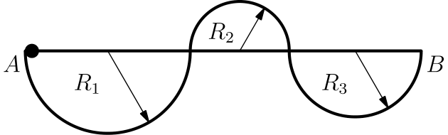
（A）238 π （B）240 π （C）260 π （D）280 π （E）500 π
English
A ball with diameter 4 inches starts at point A to roll along the track shown. The track is comprised of 3 semicircular arcs whose radii are R₁ = 100 inches, R₂ = 60 inches, and R₃ = 80 inches, respectively. The ball always remains in contact with the track and does not slip. What is the distance in inches the center of the ball travels over the course from A to B?
(A) 238 π (B) 240 π (C) 260 π (D) 280 π (E) 500 π

第二部分 解答
答案速查：
题号 1 2 3 4 5 6 7 8 9
答案 A D E C E C C C C
题号 10 11 12 13 14 15 16 17 18
答案 C D B A C B E B B
题号 19 20 21 22 23 24 25
答案 D C E E B C A
答案串：ADECECCCCCDBACBEBBDCEEBCA
第 1 题 答案 A
为了让丹妮卡把模型车排成每行正好六辆，她拥有的模型车数量必须是 6 的倍数。大于 23 的最小这样的数是 24，所以她必须再买 1 辆车。
所以正确答案是A。
English
In order for Danica to arrange her model cars in rows of exactly six, the number of model cars she has must be a multiple of six. The smallest multiple of 6 greater than 23 is 24, so she must buy 1 more car to attain this amount.
Thus,Ais the correct answer.
第 2 题 答案 D
促销时半磅价格为 $3，所以一磅促销价为 2 · $3 = $6。
促销价是正常价格的 50%，所以正常价格是促销价的两倍。因此一磅鱼的正常价格是 2 · $6 = $12。
所以正确答案是D。
English
During the sale, the price for half a pound is $3, and therefore, the price for a full pound is 2 · $3 = $6.
The sale price is 50% off the regular price, and so the regular price is twice the sale price. Therefore, the regular price for a full pound of fish is 2 · $6 = $12.
Thus,Dis the correct answer.
第 3 题 答案 E
在括号内，将相邻项配对：
(-1+2)+(-3+4)
+⋯+(-999+1000)
。
每一对的和都是 1，共有 500 对，所以括号内的值是 500。再乘以 4，得到 2000。
所以正确答案是E。
English
Within the parentheses, pair consecutive terms:
(-1+2)+(-3+4)
+⋯+(-999+1000).
Each pair has sum 1, and there are 500 pairs, so the value inside the parentheses is 500. Multiplying by 4 gives 2000.
Thus,Eis the correct answer.
第 4 题 答案 C
朱迪应付的那一份由大家额外支付的钱完全覆盖，所以她应付的金额为
7 · $2.50 = $17.50。
因为每个人原本应付相同金额，所以总账单为
8 · $17.50 = $140。
所以正确答案是C。
English
Since Judi’s portion was fully covered by everyone’s contributions, the portion of the bill she was responsible for was equal to
7 · $2.50 = $17.50.
As everyone paid the same amount, we can conclude that the total bill is
8 · $17.50 = $140.
Thus,Cis the correct answer.
第 5 题 答案 E
体重的中位数就是排序后正中间的那个值，可以这样找出：
cancel5,cancel5,6,cancel8,cancel106
因此中位数是 6 磅。
平均数可以计算如下：
(106 + 5 + 5 + 6 + 8)/5
= 130/5
= 26。
这个值比中位数大，具体来说，平均数比中位数大 20 磅。
所以正确答案是E。
English
The median weight is the middle value, which we can find as:
cancel5,cancel5,6,cancel8,cancel106
Therefore, the median is 6 pounds.
The average (mean) can be calculated to be:
(106 + 5 + 5 + 6 + 8)/5
= 130/5
= 26.
This is greater than the median, specifically, the mean is 20 pounds greater than the median.
Thus,Eis the correct answer.
第 6 题 答案 C
第二行两个数的乘积是 600，所以第二行右侧缺失的数是 600 ÷ 30 = 20。
现在知道 5 与第一行缺失数的乘积为 20。因此缺失数是 20 ÷ 5 = 4。
所以正确答案是C。
English
The product of the numbers in the second row is 600, so the missing number in the middle right box is 600 ÷ 30 = 20.
Now we know that the product of 5 and the missing number in the first row is 20. Therefore, the missing number is 20 ÷ 5 = 4.
Thus,Cis the correct answer.
第 7 题 答案 C
2 分 45 秒等于 2 · 60 + 45 = 165 秒。因为 10 秒通过 6 节车厢，所以设 165 秒通过 x 节车厢，满足
6/10=x/165。
解得
x=(165·6)/10=99。
最接近的选项是 100。
所以正确答案是C。
English
Converting 2 minutes and 45 seconds into seconds, we get 2 · 60 + 45 = 165 seconds. Since 6 cars passed in 10 seconds, at the same rate the number of cars x passing in 165 seconds satisfies
6/10=x/165.
Solving gives
x=(165·6)/10=99.
The closest answer choice is 100.
Thus,Cis the correct answer.
第 8 题 答案 C
至少有两个连续正面的结果是 HHT、THH 和 HHH。三次公平抛硬币共有 2³=8 个等可能结果，所以概率为 3/8。
所以正确答案是C。
English
The outcomes with at least two consecutive heads are HHT, THH, and HHH. There are 2³=8 equally likely outcomes from three fair coin tosses, so the probability is 3/8.
Thus,Cis the correct answer.
第 9 题 答案 C
第 n 跳时，浩克跳 2ⁿ⁻¹ 米。需要找最小的 n，使 2ⁿ⁻¹>1000。
因为 2⁹=512，而 2¹⁰=1024，所以第一次超过 1000 米时 n-1=10，即 n=11。
所以正确答案是C。
English
On the nth jump, the Hulk jumps 2ⁿ⁻¹ meters. We need the smallest n for which 2ⁿ⁻¹>1000.
Since 2⁹=512 and 2¹⁰=1024, the first jump longer than 1000 meters has n-1=10, so n=11.
Thus,Cis the correct answer.
第 10 题 答案 C
将两个数质因数分解：
180=2²·3²·5，
594=2·3³·11。
最大公因数取较小的幂，所以为 2·3²=18。最小公倍数取较大的幂，所以为
2²·3³·5·11=5940。
所求比值为 5940/18=330。
所以正确答案是C。
English
Prime-factorize the two numbers:
180=2²·3²·5,
594=2·3³·11.
The greatest common factor uses the smaller powers, so it is 2·3²=18. The least common multiple uses the larger powers, so it is
2²·3³·5·11=5940.
Therefore the desired ratio is 5940/18=330.
Thus,Cis the correct answer.
第 11 题 答案 D
祖父星期一慢跑用时 2/5 小时，星期三步行用时 2/3 小时，星期五用时 2/4=1/2 小时。换算为分钟，星期一为
2/5 · 60 = 24
分钟，星期三为
2/3 · 60 = 40
分钟，星期五为
1/2 · 60 = 30
分钟。因此实际总时间为 94 分钟。
如果他一直以每小时 4 英里的速度走，每天用时 2/4=1/2 小时，即 2/4 · 60 = 30 分钟，3 天共 3 · 30 = 90 分钟。
因此少用的时间是 94-90=4 分钟。
所以正确答案是D。
English
Grandfather spent 2/5 hours jogging on Monday. He spent 2/3 hours walking on Wednesday and 2/4=1/2 hours on Friday. Converting these times to minutes, we get
2/5 · 60 = 24
minutes for Monday,
2/3 · 60 = 40
minutes for Wednesday, and
1/2 · 60 = 30
minutes for Friday. Therefore, Grandfather totaled 94 minutes of exercise throughout the week.
If he walked at a pace of 4 miles per hour each day, he would have spent 2/4=1/2 hours each day walking. This equals 2/4 · 60 = 30 minutes every day. If he did this for 3 days, he would have totaled 3 · 30 = 90 minutes of exercise.
Therefore, Grandfather would have spent 94-90=4 fewer minutes on the treadmill.
Thus,Dis the correct answer.
第 12 题 答案 B
哈维尔第二双节省 0.40 · 50 = 20 美元。第三双节省 50/2 = 25 美元。因此他一共节省 45 美元。
因为
45/150 = 3/10 = 0.30，
所以与正常价格相比，他节省了 30 %。
所以正确答案是B。
English
Javier saved 0.40 · 50 = 20 dollars on the second pair. He also saved 50/2 = 25 dollars on the third pair. This shows that he saved a total of 45 dollars.
As
45/150 = 3/10 = 0.30,
we can conclude that Javier saved 30 % compared to the regular price.
Thus,Bis the correct answer.
第 13 题 答案 A
如果这个分数的后两位是 10a+b，交换后得到 10b+a。差为
(10a+b)-(10b+a)
= 9(a-b)，
因此错误总和与正确总和之差必须是 9 的倍数。
选项中只有 45 能被 9 整除。
所以正确答案是A。
English
If the last two digits of the score are 10a+b, then reversing those digits gives 10b+a. The difference is
(10a+b)-(10b+a)
= 9(a-b),
so the incorrect sum must differ from the correct sum by a multiple of 9.
Among the answer choices, only 45 is divisible by 9.
Thus,Ais the correct answer.
第 14 题 答案 C
艾布和比娅选择软糖共有 2·4=8 种等可能结果。颜色相同可能是两人都选绿色，有 1 种；也可能两人都选红色，有 1·2=2 种。
因此 8 个结果中有 3 个颜色相同，概率为 3/8。
所以正确答案是C。
English
There are 2·4=8 equally likely ways for Abe and Bea to choose their jelly beans. The colors match if they both choose green, which can happen in 1 way, or if they both choose red, which can happen in 1·2=2 ways.
Thus 3 of the 8 outcomes match, for probability 3/8.
Thus,Cis the correct answer.
第 15 题 答案 B
从每个方程中减去已知项：
3ᵖ=90-81=9，
2^(r)=76-44=32，
6^(s)=1421-125=1296。
因此 p=2、r=5、s=4。它们的乘积是 2·5·4=40。
所以正确答案是B。
English
Subtract the known number from each equation:
3ᵖ=90-81=9,
2^(r)=76-44=32,
6^(s)=1421-125=1296.
Therefore p=2, r=5, and s=4. Their product is 2·5·4=40.
Thus,Bis the correct answer.
第 16 题 答案 E
8 年级学生人数必须同时是 5 和 8 的倍数，所以最少为 40。这时 6 年级人数为 40 · 3/5 = 24，7 年级人数为 40 · 5/8 = 25。
因此学生总数为 40 + 24 + 25 = 89。
所以正确答案是E。
English
The number of 8th-graders must be a multiple of 5 and 8, which means that it is at least 40. Using this number, we get that the number of 6th-graders is 40 · 3/5 = 24. Similarly, the number of 7th-graders is 40 · 5/8 = 25.
The total number of students is therefore 40 + 24 + 25 = 89.
Thus,Eis the correct answer.
第 17 题 答案 B
设这六个连续整数为 x、x+1、x+2、x+3、x+4、x+5。它们的和为
6x+15=2013。
因此 6x=1998，所以 x=333。最大整数为 x+5=338。
所以正确答案是B。
English
Let the six consecutive integers be x, x+1, x+2, x+3, x+4, x+5. Their sum is
6x+15=2013.
Thus 6x=1998, so x=333. The largest integer is x+5=338.
Thus,Bis the correct answer.
第 18 题 答案 B
外表面确定的长方体体积为 12·10·5=600 立方英尺。内部空心部分在长上少 2 英尺、宽上少 2 英尺、高上少 1 英尺，所以尺寸为 10×8×4。
空心体积为 10·8·4=320 立方英尺，所以堡垒含有 600-320=280 个一英尺见方的立方块。
所以正确答案是B。
English
The rectangular prism determined by the outside faces has volume 12·10·5=600 cubic feet. The empty inside is smaller by 2 feet in length, 2 feet in width, and 1 foot in height, so its dimensions are 10×8×4.
The empty volume is 10·8·4=320 cubic feet, so the fort contains 600-320=280 one-foot cubical blocks.
Thus,Bis the correct answer.
第 19 题 答案 D
因为卡西能推断自己不是最低分，她一定比汉娜分数高。同样，布里奇特的话说明她一定比汉娜分数低。
因此从高到低的排名是卡西、汉娜、布里奇特。
所以正确答案是D。
English
Since Cassie deduced she didn’t get the lowest score, she must have got a higher score than Hannah. Similarly, Bridget’s statement reveals that she must have got a lower score than Hannah.
Therefore, the ranking from highest to lowest is Cassie, Hannah, and then Bridget.
Thus,Dis the correct answer.
第 20 题 答案 C
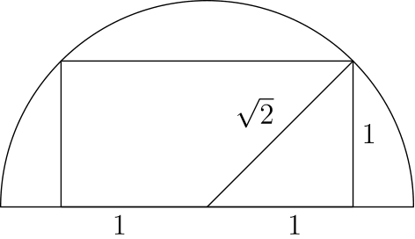
由勾股定理，半圆半径为 √(2)。因此半圆面积为
1/2 · π · √(2)² = π。
所以正确答案是C。
English
Using the Pythagorean theorem, we get that the radius of the semicircle is √(2). This means that the area of the semicircle is
1/2 · π · √(2)² = π.
Thus,Cis the correct answer.
第 21 题 答案 E
为了最快到达公园西南角，萨曼莎必须向东走 2 个街区、向北走 1 个街区，这些步骤可排列成 3 种方式。经过公园对角线小路后，她必须再向东走 2 个街区、向北走 2 个街区到学校，这些步骤可排列成 C(4, 2)=6 种方式。
公园前后的选择相互独立，所以最短路线总数为 3·6=18。
所以正确答案是E。
English
To reach the southwest corner of the park as quickly as possible, Samantha must go 2 blocks east and 1 block north, which can be arranged in 3 ways. After the diagonal path through the park, she must go 2 blocks east and 2 blocks north to reach school, which can be arranged in C(4, 2)=6 ways.
The choices before and after the park are independent, so the total number of shortest routes is 3·6=18.
Thus,Eis the correct answer.
第 22 题 答案 E
一个 60 乘 32 网格有 61 条竖直网格线，每条由 32 根牙签组成；还有 33 条水平网格线，每条由 60 根牙签组成。
因此牙签总数为
61·32+33·60 = 1952+1980
= 3932
。
所以正确答案是E。
English
A 60-by-32 grid has 61 vertical grid lines, each made of 32 toothpicks, and 33 horizontal grid lines, each made of 60 toothpicks.
Therefore the total number of toothpicks is
61·32+33·60 = 1952+1980
= 3932.
Thus,Eis the correct answer.
第 23 题 答案 B
AB 上的半圆面积为 8π，所以对应整圆面积为 16π。其半径为 4，因此 AB=8。
半径为 r 的半圆弧长为 π r。因为 AC 上的弧长为 8.5π，其半径为 8.5，所以 AC=17。
在直角三角形 ABC 中，由勾股定理，
BC=√(17²-8²)=√(225)=15。
因此 BC 上半圆的半径为 15/2=7.5。
所以正确答案是B。
English
The semicircle on AB has area 8π, so its full circle would have area 16π. Its radius is therefore 4, and AB=8.
A semicircle of radius r has arc length π r. Since the arc on AC has length 8.5π, its radius is 8.5, so AC=17.
Using the Pythagorean theorem in right triangle ABC,
BC=√(17²-8²)=√(225)=15.
The radius of the semicircle on BC is 15/2=7.5.
Thus,Bis the correct answer.
第 24 题 答案 C
设每个正方形边长为 1，则三个正方形总面积为 3。从总面积中减去对角线 AJ 左侧的非阴影区域会更容易。
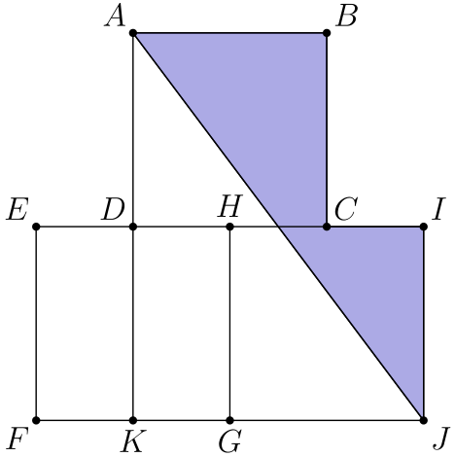
根据解答图，长方形 EDKF 面积为 1·1/2=1/2，三角形 AKJ 面积为
1/2·3/2·2=3/2。
因此非阴影面积为 1/2+3/2=2，阴影五边形面积为 3-2=1。
所求比值为 1/3。
所以正确答案是C。
English
Let each square have side length 1, so the total area of the three squares is 3. It is easier to subtract the unshaded region to the left of diagonal AJ from this total.
Using the solution diagram, rectangle EDKF has area 1·1/2=1/2, and triangle AKJ has area
1/2·3/2·2=3/2.
Thus the unshaded area is 1/2+3/2=2, so the shaded pentagon has area 3-2=1.
The requested ratio is 1/3.
Thus,Cis the correct answer.
第 25 题 答案 A
球的半径为 2。滚动时，球心沿着与轨道平行的半圆弧运动。第一段和第三段圆弧中球心路径在轨道圆弧内侧，所以半径分别为 100-2=98 和 80-2=78。中间圆弧中球心路径在轨道圆弧外侧，所以半径为 60+2=62。
球心行进的总距离是三段半圆弧长度之和：
(98+62+78)π=238π。
所以正确答案是A。
English
The ball has radius 2. As the ball rolls, its center follows semicircular arcs parallel to the track. On the first and third arcs the center path is inside the track arcs, so those radii are 100-2=98 and 80-2=78. On the middle arc the center path is outside the track arc, so that radius is 60+2=62.
The total distance traveled by the center is the sum of the three semicircle lengths:
(98+62+78)π=238π.
Thus,Ais the correct answer.

